**Home page, Sign up, Tutorial and instructions**

**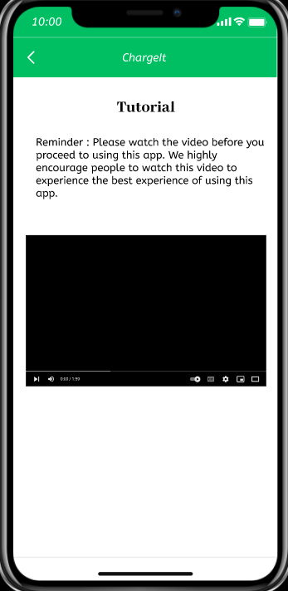

**Login, home page, book EV charger station, plan route features**

Fee

**Delete booking feature, giving feedback**

